HTTP stands for Hyper Text Transfer Protocol

HTTP Request / Response

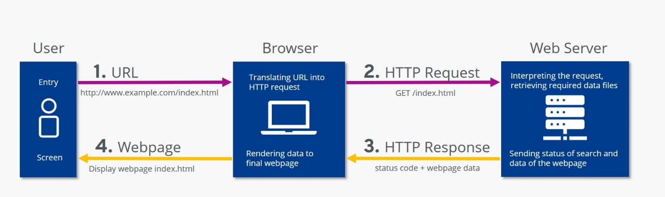Communication between clients and servers is done by requests and responses:

1. A client (a browser) sends an HTTP request to the web

2. A web server receives the request

3. The server runs an application to process the request

4. The server returns an HTTP response (output) to the browser

5. The client (the browser) receives the response

----------------------------------------------

HTTPS is the secure version of HTTP

SSl certificate >> protect HTTP file

***>>HTTP is an application protocol that dictates how the information on the World Wide Web travels, whereas***

***>>HTML dictates how the Web pages are formatted and displayed****.*

*HTTP is the system that tells Web data how to go from one place to another, while HTML is the language in which Web pages are written*

************* **HTML** **************************

>HTML stands for Hyper Text Markup **Language**!!!

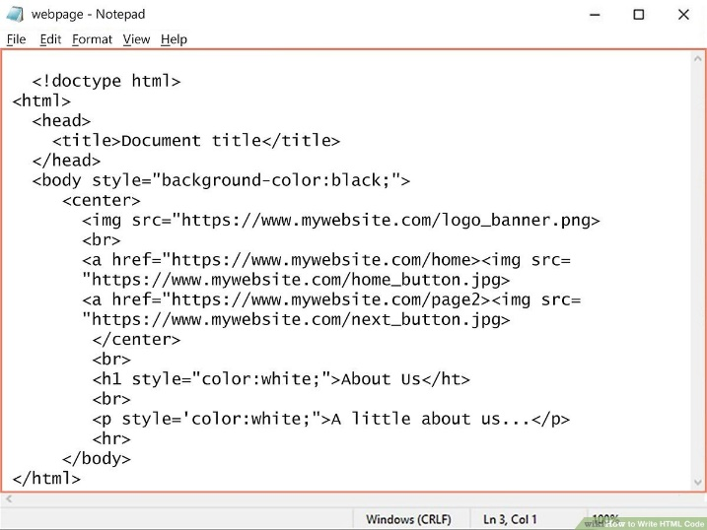>HTML is the standard markup language for creating Web pages

>HTML describes the structure of a Web page

>HTML consists of a series of elements

>HTML elements tell the browser how to display the content

>HTML elements label pieces of content such as "this is a heading", "this is a paragraph", "this is a link", etc.